**Students Exams Management System**

**Done By**

Hend Hany Elkadeem

Mahmoud Mohamed Elframawi

Mahmoud Ahmed Mohamed Enany

Abdelrahman Salah Amin

Ahmed Mamdouh Abd El-Ghany

# Abstract

This project is a web-based Examination Management System designed to manage the complete exam process, from exam creation by instructors to exam submission and evaluation by students. The system follows a role-based structure that ensures clear separation of responsibilities and secure handling of academic data.

The system supports three main user roles: **Admin**, **Instructor**, and **Student**. Students can log in to view their assigned courses, take online exams, submit answers, and review their grades. Instructors are able to create exams, and add questions to the system. Administrators have full control over the platform, including managing student and instructor accounts.

The front-end is developed using **React**, providing a responsive and interactive user interface. The back-end is implemented using **Node.js**, which handles business logic, authentication, and communication with the database through secure APIs. **Microsoft SQL Server** is used to store and manage system data efficiently.

Contents

Abstract 2

Database 5

System Requirements 5

ER Diagram 8

Mapping 9

Tables 10

Admin 10

br_dept 10

Branch 10

Choice 10

Course 11

Dep_Ins 11

Department 11

Exam 12

Exam_Question 12

Instructor 12

Question 13

st_crs_grade 13

Student 14

Student_Exam_Answer 14

Student_University 15

StudentMajor 15

Topic 15

Stored Procedures 15

Exam generation 15

Exam Answers 19

Exam Correction 20

Reports 22

Report 1 22

Report 2 24

Report 3 26

Report 4 28

Report 5 29

Report 6 31

Interface 34

Technology Stack 34

Frontend Libraries & Tools 34

User Roles 34

Questions Management 35

Exam 38

Exam Lifecycle (Core Flow) 38

Student Exam Flow 41

Assign Student to Course 43

# Database

## System Requirements

1. The system shall store and manage **branch data**, including branch ID and branch name.

2. The system shall store and manage **department data**, including department ID, name, and location.

3. The system shall enforce that **each branch must be associated with one or more departments**, while a department may be associated with zero or more branches.

4. The system shall store and manage **instructor data**, including ID, name, email, password, hire date, degree, and salary.

5. The system shall enforce that **each instructor must belong to at least one department**, and each department must have one or more instructors.

6. The system shall support assigning **one instructor as a manager for each department**, while an instructor may manage zero or one department.

7. The system shall store and manage **student data**, including ID, name, email, password, and address.

8. The system shall enforce that **each student must be assigned to exactly one department**, while a department may have zero or more students.

9. The system shall store and manage **course data**, including course ID, name, duration, and multi-valued topics.

10. The system shall enforce that **each course belongs to exactly one department**, while each department must offer one or more courses.

11. The system shall support a **many-to-many relationship between students and courses**, where each student must be enrolled in one or more courses, and each course may have zero or more students.

12. The system shall store additional data for student–course enrollment, including **grade and assignment date**.

13. The system shall support a **many-to-many relationship between instructors and courses**, ensuring that each course must be taught by one or more instructors and each instructor may teach multiple courses.

14. The system shall store and manage **question data**, including question ID, question text, question type, default score, correct choice, and difficulty level.

15. The system shall allow each question to be associated with **one or more courses**, while a course may have zero or more questions.

16. The system shall store and manage **exam data**, including exam ID, total score, and duration.

17. The system shall enforce that **each exam must include multiple questions**, while a question may appear in zero or more exams.

18. The system shall support a **many-to-many relationship between students and exams**, where each student may take one or more exams and each exam must be taken by multiple students.

19. The system shall store **score per question** for each student in an exam.

20. The system shall store and manage **choice data**, including choice ID and choice text.

21. The system shall enforce that **each choice belongs to exactly one question**, and each question must have one or more choices.

22. The system shall store and manage **university data**, including university ID and name.

23. The system shall enforce that **each student must belong to exactly one university**, while a university may have many students.

24. The system shall store and manage **major data**, including major ID and name.

25. The system shall enforce that **each student must belong to exactly one major**, while a major may have many students.

26. The system shall store and manage **student answers** for exams through an answer relationship that combines student, exam, and question.

27. The system shall store answer attributes including **student answer, score, and correctness status**.

28. The system shall store and manage **admin data**, including admin ID, full name, email, and password.

29. The system shall allow administrators to **manage system data** and oversee system operations.

## ER Diagram

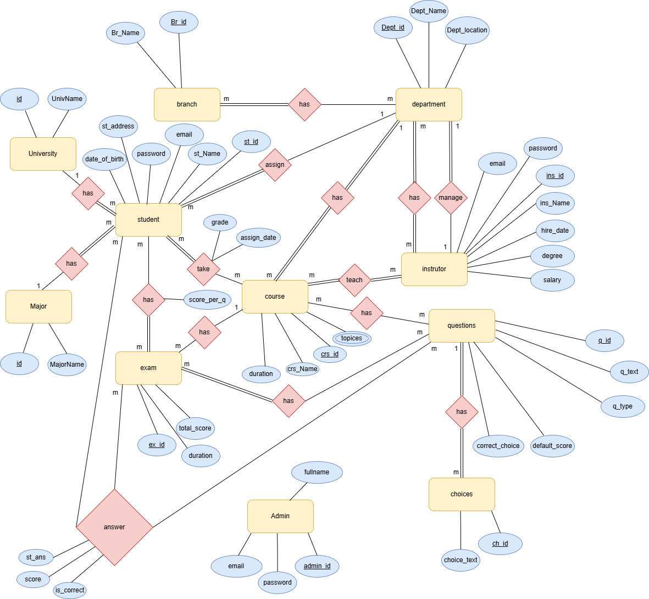

## Mapping

## Tables

The system contians 18 tables, we will move through them step by step

### Admin

CREATE TABLE Admin

(

admin_id INT IDENTITY(1,1) PRIMARY KEY,

email NVARCHAR(100) NOT NULL UNIQUE,

password NVARCHAR(255) NOT NULL,

full_name NVARCHAR(100) NULL

);

### br_dept

CREATE TABLE br_dept

(

Dept_id INT NOT NULL,

Br_id INT NOT NULL,

PRIMARY KEY (Dept_id, Br_id),

FOREIGN KEY (Dept_id) REFERENCES Department(Dept_id),

FOREIGN KEY (Br_id) REFERENCES Branch(Br_id)

);

### Branch

CREATE TABLE Branch

(

Br_id INT IDENTITY(1,1) PRIMARY KEY,

Br_name NVARCHAR(50) NOT NULL

);

### Choice

CREATE TABLE Choice

(

ch_id INT IDENTITY(1,1) PRIMARY KEY,

choice_text NVARCHAR(MAX) NOT NULL,

q_id INT NOT NULL,

FOREIGN KEY (q_id) REFERENCES Question(q_id)

ON UPDATE CASCADE

ON DELETE CASCADE

);

### Course

CREATE TABLE Course

(

crs_id INT PRIMARY KEY,

crs_name NVARCHAR(50) NULL,

duration INT NULL,

Dept_id INT NOT NULL,

FOREIGN KEY (Dept_id) REFERENCES Department(Dept_id)

);

### Dep_Ins

CREATE TABLE Dep_Ins

(

Dept_id INT NOT NULL,

ins_id INT NOT NULL,

PRIMARY KEY (Dept_id, ins_id),

FOREIGN KEY (Dept_id) REFERENCES Department(Dept_id)

ON UPDATE CASCADE

ON DELETE CASCADE,

FOREIGN KEY (ins_id) REFERENCES Instructor(ins_id)

ON UPDATE CASCADE

ON DELETE CASCADE

);

### Department

CREATE TABLE Department

(

Dept_id INT PRIMARY KEY,

Dept_name NVARCHAR(50) NOT NULL,

Dept_location NVARCHAR(50) NOT NULL,

manager_id INT NULL,

FOREIGN KEY (manager_id) REFERENCES Instructor(ins_id));

### Exam

CREATE TABLE Exam

(

ex_id INT IDENTITY(1,1) PRIMARY KEY,

duration INT NOT NULL,

total_score INT NOT NULL,

date DATETIME DEFAULT GETDATE(),

crs_id INT NOT NULL,

ins_id INT NOT NULL,

is_submitted BIT DEFAULT 0,

FOREIGN KEY (crs_id) REFERENCES Course(crs_id)

ON UPDATE CASCADE

ON DELETE CASCADE,

FOREIGN KEY (ins_id) REFERENCES Instructor(ins_id)

ON UPDATE CASCADE

ON DELETE CASCADE

);

### Exam_Question

CREATE TABLE Exam_Question

(

ex_ID INT NOT NULL,

q_ID INT NOT NULL,

degree INT NOT NULL,

PRIMARY KEY (ex_ID, q_ID),

FOREIGN KEY (ex_ID) REFERENCES Exam(ex_id),

FOREIGN KEY (q_ID) REFERENCES Question(q_id)

);

### Instructor

CREATE TABLE Instructor

(

ins_id INT IDENTITY(1,1) PRIMARY KEY,

ins_name VARCHAR(50) NOT NULL,

degree VARCHAR(20) NULL,

hire_date DATE DEFAULT GETDATE(),

salary FLOAT NOT NULL,

Dept_id INT NULL,

ins_email NVARCHAR(100) NULL,

ins_password NVARCHAR(100) NULL,

FOREIGN KEY (Dept_id) REFERENCES Department(Dept_id)

);

Instructor_course

CREATE TABLE Instructor_Course

(

instructor_ID INT NOT NULL,

course_ID INT NOT NULL,

PRIMARY KEY (instructor_ID, course_ID),

FOREIGN KEY (instructor_ID) REFERENCES Instructor(ins_id),

FOREIGN KEY (course_ID) REFERENCES Course(crs_id)

);

### Question

CREATE TABLE Question

(

q_id INT IDENTITY(1,1) PRIMARY KEY,

q_text NVARCHAR(MAX) NOT NULL,

q_type NVARCHAR(20) NOT NULL,

default_score FLOAT NOT NULL,

correct_choice NVARCHAR(MAX) NOT NULL,

crs_id INT NULL,

top_id INT NOT NULL,

FOREIGN KEY (crs_id) REFERENCES Course(crs_id)

ON UPDATE CASCADE

ON DELETE CASCADE,

FOREIGN KEY (top_id) REFERENCES Topic(topic_id)

);

### st_crs_grade

CREATE TABLE st_crs_grade

(

st_id INT NOT NULL,

crs_id INT NOT NULL,

grade INT NULL,

PRIMARY KEY (st_id, crs_id),

FOREIGN KEY (st_id) REFERENCES Student(st_id),

FOREIGN KEY (crs_id) REFERENCES Course(crs_id)

);

### Student

CREATE TABLE Student

(

st_id INT IDENTITY(1,1) PRIMARY KEY,

st_name NVARCHAR(50) NOT NULL,

st_address NVARCHAR(100) NULL,

Dept_id INT NOT NULL,

DateOfBirth DATE NULL,

Univ_id INT NULL,

Major_id INT NULL,

st_email NVARCHAR(100) NULL,

st_password NVARCHAR(100) NULL,

FOREIGN KEY (Dept_id) REFERENCES Department(Dept_id) ON UPDATE CASCADE ON DELETE CASCADE,

FOREIGN KEY (Major_id) REFERENCES StudentMajor(MajorID),

FOREIGN KEY (Univ_id) REFERENCES Student_University(Univ_id)

);

### Student_Exam_Answer

CREATE TABLE Student_Exam_Answer

(

student_ID INT NOT NULL,

exam_ID INT NOT NULL,

question_ID INT NOT NULL,

student_Answer NVARCHAR(250) NOT NULL,

isCorrect BIT NULL,

score INT NULL,

PRIMARY KEY (student_ID, exam_ID, question_ID),

FOREIGN KEY (student_ID) REFERENCES Student(st_id),

FOREIGN KEY (exam_ID) REFERENCES Exam(ex_id),

FOREIGN KEY (question_ID) REFERENCES Question(q_id)

);

### Student_University

CREATE TABLE Student_University

(

Univ_id INT IDENTITY(1,1) PRIMARY KEY,

univ_name NVARCHAR(50) NOT NULL

);

### StudentMajor

CREATE TABLE StudentMajor

(

MajorID INT IDENTITY(1,1) PRIMARY KEY,

MajorName NVARCHAR(50) NOT NULL

);

### Topic

CREATE TABLE Topic

(

topic_id INT PRIMARY KEY,

topic_name NVARCHAR(50) NULL,

crs_id INT NOT NULL,

FOREIGN KEY (crs_id) REFERENCES Course(crs_id)

);

## Stored Procedures

### Exam generation

CREATE OR ALTER PROC sp_generate_exam

@ex_id INT,

@mcq_cnt INT,

@tf_cnt INT,

@mode NVARCHAR(20)

AS

BEGIN

DECLARE @easy_pct FLOAT, @med_pct FLOAT, @hard_pct FLOAT;

IF @mode = 'hard'

BEGIN

SET @easy_pct = 0.1;

SET @med_pct = 0.3;

SET @hard_pct = 0.6;

END

ELSE IF @mode = 'easy'

BEGIN

SET @easy_pct = 0.6;

SET @med_pct = 0.3;

SET @hard_pct = 0.1;

END

ELSE

BEGIN

SET @easy_pct = 0.2;

SET @med_pct = 0.6;

SET @hard_pct = 0.2;

END

DECLARE @crs_id INT;

SELECT @crs_id = crs_id FROM exam WHERE ex_id = @ex_id;

INSERT INTO exam_question (ex_id, q_id, degree)

SELECT TOP (CAST(CEILING(@mcq_cnt * @easy_pct) AS INT))

@ex_id, q_id, default_score

FROM question

WHERE crs_id = @crs_id AND q_type = 'mcq' AND default_score BETWEEN 1 AND 2

ORDER BY NEWID();

INSERT INTO exam_question (ex_id, q_id, degree)

SELECT TOP (CAST(CEILING(@mcq_cnt * @med_pct) AS INT))

@ex_id, q_id, default_score

FROM question

WHERE crs_id = @crs_id AND q_type = 'mcq' AND default_score BETWEEN 3 AND 5

ORDER BY NEWID();

INSERT INTO exam_question (ex_id, q_id, degree)

SELECT TOP (CAST(CEILING(@mcq_cnt * @hard_pct) AS INT))

@ex_id, q_id, default_score

FROM question

WHERE crs_id = @crs_id AND q_type = 'mcq' AND default_score > 5

ORDER BY NEWID();

INSERT INTO exam_question (ex_id, q_id, degree)

SELECT TOP (CAST(CEILING(@tf_cnt * @easy_pct) AS INT))

@ex_id, q_id, default_score

FROM question

WHERE crs_id = @crs_id AND q_type = 'tf' AND default_score BETWEEN 1 AND 2

ORDER BY NEWID();

INSERT INTO exam_question (ex_id, q_id, degree)

SELECT TOP (CAST(CEILING(@tf_cnt * @med_pct) AS INT))

@ex_id, q_id, default_score

FROM question

WHERE crs_id = @crs_id AND q_type = 'tf' AND default_score BETWEEN 3 AND 5

ORDER BY NEWID();

INSERT INTO exam_question (ex_id, q_id, degree)

SELECT TOP (CAST(CEILING(@tf_cnt * @hard_pct) AS INT))

@ex_id, q_id, default_score

FROM question

WHERE crs_id = @crs_id AND q_type = 'tf' AND default_score>5

ORDER BY NEWID();

END;

**Overview:**

sp_generate_exam is a stored procedure that automatically generates an exam by selecting random MCQ and True/False questions based on difficulty mode.

**Parameters:**

- @ex_id: Exam ID

- @mcq_cnt: Number of MCQ questions

- @tf_cnt: Number of True/False questions

- @mode: Difficulty mode (easy, normal, hard)

**Difficulty Distribution:**

Easy Mode -> 60% Easy, 30% Medium, 10% Hard

Normal Mode -> 20% Easy, 60% Medium, 20% Hard

Hard Mode -> 10% Easy, 30% Medium, 60% Hard

**Difficulty Classification:**

Easy -> default_score between 1 and 2

Medium -> default_score between 3 and 5

Hard -> default_score > 5

**Tables Used:**

- exam (to get course ID)

- question (source of questions)

- exam_question (generated exam questions)

**Randomization:**

Uses ORDER BY NEWID() to randomize question selection.

**Example Usage:**

EXEC sp_generate_exam 5, 20, 10, 'hard';

**Notes:**

- No duplicate check if executed multiple times.

- Ensure sufficient questions exist per difficulty level.

### Exam Answers

CREATE PROCEDURE [dbo].[sp_ExamAnswers]

(

@Student_ID INT,

@Exam_ID INT,

@Question_ID INT,

@Student_Answer NVARCHAR(250)

)

AS

BEGIN

INSERT INTO Student_Exam_Answer

VALUES

(

@Student_ID,

@Exam_ID,

@Question_ID,

@Student_Answer,

NULL,

NULL

);

END

**Overview:**

The sp_ExamAnswers stored procedure is used to store a student’s answer for a specific question in a specific exam. It inserts the student’s response into the Student_Exam_Answer table.

**Input Parameters:**

|  |  |
| --- | --- |
| Parameter Name | Description |
| @Student_ID | Unique identifier of the student |
| @Exam_ID | Unique identifier of the exam |
| @Question_ID | Unique identifier of the question |
| @Student_Answer | The answer selected or entered by the student |

**Logic Description :**

1. Receives the student, exam, and question identifiers.
2. Stores the student’s answer without validation or correction.
3. Leaves correction-related columns empty for later processing.

### Exam Correction

CREATE PROCEDURE [dbo].[sp_ExamCorrection]

(

@student_ID INT,

@exam_ID INT

)

AS

BEGIN

UPDATE SEA

SET

isCorrect = CASE

WHEN SEA.student_Answer = Q.correct_choice THEN 1

ELSE 0

END,

score = CASE

WHEN SEA.student_Answer = Q.correct_choice THEN EQ.degree

ELSE 0

END

FROM Student_Exam_Answer SEA

INNER JOIN Question Q ON SEA.question_ID = Q.q_id

INNER JOIN Exam_Question EQ ON EQ.q_ID = Q.q_id

WHERE SEA.student_ID = @student_ID

AND SEA.exam_ID = @exam_ID;

-- Calculate total score and maximum score

DECLARE @totalScore INT;

DECLARE @maxScore INT;

-- Assign total score obtained by the student

SELECT @totalScore = SUM(score)

FROM Student_Exam_Answer

WHERE student_ID = @student_ID

AND exam_ID = @exam_ID;

-- Assign maximum possible score for the exam

SELECT @maxScore = SUM(EQ.degree)

FROM Exam_Question EQ

INNER JOIN Question Q ON EQ.q_ID = Q.q_id

WHERE EQ.ex_ID = @exam_ID;

SELECT

@student_ID AS Student_ID,

@exam_ID AS Exam_ID,

@totalScore AS Total_Score,

@maxScore AS Full_Mark,

CAST((@totalScore * 100.0 / @maxScore) AS DECIMAL(5, 2)) AS Percentage;

END

**Overview** **:**

The sp_ExamCorrection stored procedure is responsible for:

* Correcting the student’s exam automatically.
* Updating correctness and score per question.
* Calculating the total score and percentage result.

**Input Parameters** **:**

|  |  |  |
| --- | --- | --- |
| Parameter Name | Data Type | Description |
| @student_ID | int | Unique identifier of the student |
| @exam_ID | int | Unique identifier of the exam |

**Correction Logic (Question Level)**

This part compares the student’s answers with the correct answers stored in the Question table.

***Actions Performed:***

* Updates the isCorrect column:
* 1 if the student answer matches the correct choice.
* 0 otherwise.
* Updates the score column:
* Assigns default_score if the answer is correct.
* Assigns 0 if the answer is incorrect.

This is achieved using:

* CASE expressions for conditional logic.
* INNER JOIN between Student_Exam_Answer and Question tables.

## Reports

### Report 1

Report that returns the students information according to Department No parameter.

**GetStudentsByDeptID**

CREATE PROCEDURE GetStudentsByDeptID @dept_ID INT

AS

BEGIN

SELECT S.st_id[ID], S.st_name[Student Name], S.st_address [Government], D.Dept_name[Department],

U.univ_name[University], M.MajorName[Major], YEAR(GETDATE())- YEAR(DateOfBirth)[Age]

FROM student S

inner join student_university U

ON S.Univ_id = U.Univ_id

inner join StudentMajor M

ON S.Major_id = M.MajorID

inner join Department D

ON D.Dept_id = S.Dept_id

WHERE D.Dept_id = @dept_ID

END

**Purpose:** Retrieve all students who belong to a specific department.

**Execution behavior:**

* The procedure takes a department ID.
* It looks in the student table for all students linked to that department.
* It joins with other tables (student_university, StudentMajor, Department) to get extra details like university name, major name, and department name.
* It also calculates the student’s age by subtracting the year of birth from the current year.

**Input:**

* @dept_ID → the department ID you want to filter by.

**Output:** A result set with these columns:

* Student ID
* Student Name
* Address (Government)
* Department Name
* University Name
* Major Name
* Age (calculated from DateOfBirth).

Report 1 : Get Student By Department ID

### Report 2

Report that takes the student ID and returns the grades of the student in all courses. %

**SP_Student_Grades**

CREATE PROCEDURE [dbo].[SP_Student_Grades]

(

@St_id INT

)

AS

BEGIN

SET NOCOUNT ON;

SELECT

c.crs_id,

c.crs_name,

sc.grade,

CASE

WHEN sc.grade >= 60 THEN 'Pass'

ELSE 'Fail'

END AS status

FROM st_crs_grade sc

INNER JOIN Course c

ON sc.crs_id = c.crs_id

WHERE sc.st_id = @St_id;

END

**Purpose:** Retrieve all grades for a specific student across all courses.

**Execution behavior:**

* When you run this procedure, the database looks into the st_crs_grade table (where student grades are stored).
* It matches the student ID you provide (@St_id).
* It joins with the Course table to get the course names.
* It also joins with the student table to get the student’s name.
* Finally, it returns a list of all courses that student has taken, with the grade in each.

**Input:**

* @St_id → the student’s ID (INT).

**Output:** A result set with four columns:

* Student ID
* Student Name
* Course Name
* Grade (percentage or score).

Reposrt 2 : Student Grade in all courses

### Report 3

Report that takes the instructor ID and returns the name of the courses that he teaches and the number of student per course.

**SP_InstructorCoursesReport**

CREATE PROCEDURE [dbo].[SP_InstructorCoursesReport] @InstructorID INT

AS

SELECT

I.ins_name [Instructor],c.crs_name AS CourseName,

COUNT(scg.st_id) AS StudentCount

FROM instructor_Course ic INNER JOIN Course c

ON ic.course_ID = c.crs_id

LEFT JOIN st_crs_grade scg

ON c.crs_id = scg.crs_id

inner join Instructor I

on ic.instructor_ID = I.ins_id

WHERE ic.instructor_ID = @InstructorID

GROUP BY c.crs_name, I.ins_name;

**Purpose:** Generate a report of all courses taught by a specific instructor, along with the number of students enrolled in each course.

**Execution behavior:**

* The procedure starts from the instructor_Course table to find which courses are linked to the instructor ID you provide.
* It joins with the Course table to get the course names.
* It joins with the Instructor table to get the instructor’s name.
* It uses a **LEFT JOIN** with st_crs_grade to count how many students are enrolled in each course (even if some courses have zero students, they will still appear).
* Finally, it groups the results by course name and instructor name so you get one row per course.

**Input:**

* @InstructorID → the instructor’s ID (INT).

**Output:** A result set with three columns:

* Instructor name
* Course name
* Student count (number of students enrolled in that course).

Report 3 : Get courses names that an instructor teaches

### Report 4

Report that takes course ID and returns its topics

**SP_CourseTopicsReport**

CREATE PROCEDURE [dbo].[SP_CourseTopicsReport]

@CourseID INT

AS

SELECT

c.crs_name AS CourseName,

t.topic_name AS TopicName

FROM Course c

INNER JOIN Topic t

ON c.crs_id = t.crs_id

WHERE c.crs_id = @CourseID;

**Purpose:** Retrieve all topics that belong to a specific course.

**Execution behavior:**

* The procedure takes a course ID (@CourseID).
* It looks in the Course table to find the course.
* It joins with the Topic table to get all topics linked to that course.
* It then returns one row for each topic inside that course.

**Input:**

* @CourseID → the ID of the course you want to see topics for.

**Output:** A result set with two columns:

* Course name
* Topic name

Report 4 : Topics in Course

### Report 5

Report that takes exam number and returns the Questions in it and choices

**SP_ExamQuestionsChoices**

CREATE PROCEDURE [dbo].[SP_ExamQuestionsChoices] @ExamID INT

AS

BEGIN

SELECT

e.ex_ID,

q.q_id,

q.q_text,

q.q_type,

q.correct_choice,

STRING_AGG(

CASE WHEN c.choice_text <> q.correct_choice THEN c.choice_text END, ', '

) WITHIN GROUP (ORDER BY c.ch_id) AS WrongChoices

FROM Exam_Question e

INNER JOIN Question q

ON e.q_ID = q.q_id

LEFT JOIN Choice c

ON q.q_id = c.q_id

WHERE e.ex_ID = @ExamID

GROUP BY e.ex_ID, q.q_id, q.q_text, q.correct_choice,q.q_type;

END;

**Purpose:** Retrieve all questions of a specific exam, along with their correct answer and all wrong choices.

**Execution behavior:**

* The procedure takes an exam ID (@ExamID).
* It looks in the Exam_Question table to find all questions linked to that exam.
* It joins with the Question table to get the question text, type, and correct choice.
* It joins with the Choice table to collect all possible choices.
* It uses STRING_AGG to combine all wrong choices into one string, separated by commas, ordered by choice ID.
* Finally, it groups the results so you get one row per question with its correct and wrong choices.

**Input:**

* @ExamID → the exam’s ID (INT).

**Output:** A result set with:

* Exam ID
* Question ID
* •Question text
* Question type (MCQ, True/False, etc.)
* Correct choice
* Wrong choices (all combined in one column).

Report 5 : Exam Questions & Choices

### Report 6

Report that takes exam number and the student ID then returns the Questions in this exam with the student answers.

**GetExamStudentAnswers**

CREATE PROCEDURE [dbo].[GetExamStudentAnswers]

(

@STUDENT_ID INT,

@EXAM_ID INT

)

AS

BEGIN

SELECT SEA.student_ID AS [Student ID], S.st_name AS [Student Name],

SEA.exam_ID AS [Exam ID], SEA.question_ID AS [Question ID], Q.q_text AS [Question ], Q.q_type AS [Question Type],

Q.correct_choice AS [Correct Answer], SEA.student_Answer AS [student Answer], SEA.isCorrect AS [Result],

SEA.score AS [Student Score]

FROM Student_Exam_Answer SEA

INNER JOIN Question Q

ON SEA.question_ID = Q.q_id

INNER JOIN Student S

ON S.st_id = SEA.student_ID

END

**Purpose:** Retrieve detailed information about a student’s answers in a specific exam.

**Execution behavior:**

* The procedure takes two parameters: student ID and exam ID.
* It looks in the Student_Exam_Answer table to find all answers that student gave in that exam.
* It joins with the Question table to get the question text, type, and correct answer.
* It joins with the Student table to get the student’s name.
* It then returns one row per question, showing both the student’s answer and whether it was correct.

**Input:**

* @STUDENT_ID → the student’s ID (INT).
* @EXAM_ID → the exam’s ID (INT).

**Output:** A result set with:

* Student ID
* Student Name
* Exam ID
* Question ID
* Question text
* Question type (MCQ, True/False, etc.)
* Correct answer
* Student’s answer
* Result (whether the answer is correct or not)
* Student’s score for that question

Report 6 : Student Answers in Exam

# Interface

## Technology Stack

### Frontend Libraries & Tools

* **React 19.2.0** – Component-based UI and state management
* **Vite 7.2.4** – Fast development server and build tool
* **Tailwind CSS 3.4.19** – Utility-first CSS framework
* **Axios 1.13.2** – HTTP client for API communication
* **React Router DOM 7.11.0** – Client-side routing

## User Roles

**1. Admin**

* Assign students to courses
* Display exams

**2. Instructor**

* Create exams
* Generate and regenerate questions
* Update exam settings (duration / question counts)
* Submit and finalize exams

**3. Student**

* Access assigned exams
* Take exams within a controlled time window
* Submit answers manually or automatically when time ends

Login Page

## Questions Management

Instructors have the ability to manage questions within the system, including adding new questions, editing existing ones, and deleting questions when needed. Each question can be categorized by its type, such as multiple-choice, **true/false**, or **short-answer**, allowing for better organization and flexible exam creation.

**APIs for Questions management:**

* POST /api/questions – Add a question
* PUT /api/questions/:id – Update a question
* DELETE /api/questions/:id – Delete a question
* GET /api/questions/:examId – Get all questions

Question Bank

Adding New Question to the Question Bank

Inserting Answers to Question

## Exam

### Exam Lifecycle (Core Flow)

#### Step 1: Create Empty Exam

1. Instructor selects course and duration
2. Frontend sends: POST /api/exams
3. Backend creates an empty exam record

Generating Exam

Choosing number and type of questions

#### Step 2: Generate Exam Questions

1. Instructor specifies number of MCQ and True/False questions
2. Frontend sends: POST /api/exams/generate
3. Questions are attached to the existing exam

Important: Frontend **does not regenerate automatically** to avoid duplicated questions.

Generated Exam

#### Step 3: Update Exam

1. Instructor updates:

* Duration
* MCQ / TF counts

1. Frontend sends: PUT /api/exams/:id

#### Step 4: Regenerate Exam

1. Instructor may regenerate questions manually
2. Old questions are replaced (not appended)
3. Controlled action to avoid accidental duplication

Exam Questions

#### Step 5: Submit Exam (Instructor)

1. Locks exam for students : POST /api/exams/submit

Exam Submission

### Student Exam Flow

#### Step 1: Fetch Exam & Questions

GET /api/student/exam/:id/questions

Response includes:

* startTime
* durationMinutes
* questions[]

#### Step 2: Secure Timer Logic (Server-Based)

Timer **does NOT use localStorage**

If student refreshes → timer continues correctly

#### Step 3: Answering Questions

* Student answers stored locally (for navigation only)
* Options shuffled per question

#### Step 4: Auto Submit

* When remaining time reaches zero:

POST /api/student/exam/submit

Exam View

Time Slider during exam solving

Submitting Exam

Grades Dashboard

## Assign Student to Course

**API Usage from Frontend Perspective:**

POST /api/courses/assign

Body: { st_id, crs_id }

Used by: **Admin / Instructor**

Courses Assignement Dashboard

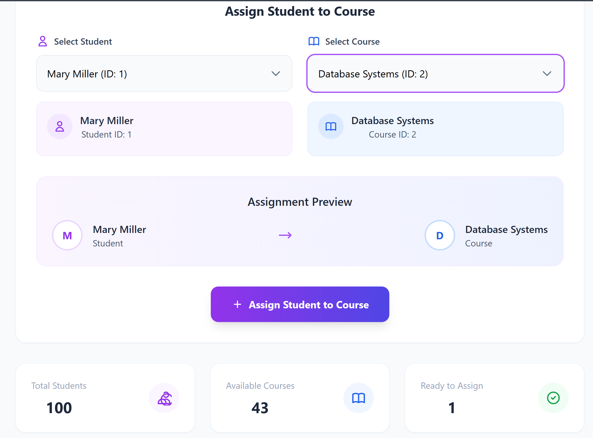

Assigning Student to Course

Student Courses Dashboard